

danearts.com
Dane Arts presents power2give.org, an online cultural marketplace linking passion and creativity. The site invites artists and organizations to post and promote local arts, culture and history projects for which they seek funding. It invites individual donors to bring them to life through their gifts. And it invites community supporters to provide matching dollars.
With tools for donors, individuals and organizations, power2give.org makes posting projects, promoting them to different audiences, giving $ in support of donors’ interests, and engaging with one another in our community easy, rewarding and fun for all involved. Find your passion, give and make a difference!
With tools and resources for donors, individuals and

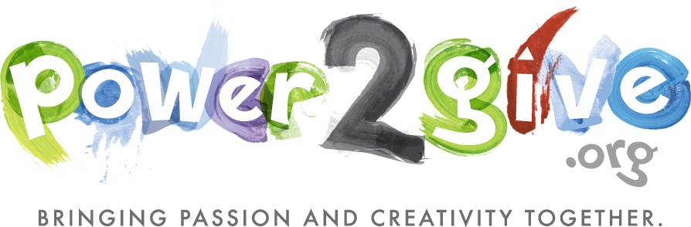
www.power2give.org/danearts/Project/ProjectListing
Projects seeking funding:
Bach Dancing & Dynamite Society, Bring Daniel Panner to Madison!
Bach Dancing & Dynamite Society, Bring Katarzyna Bryla to Madison!
Bach Dancing & Dynamite Society, Visual Dynamite for our Concert!
Brenda Baker, Derrick Buisch & Bird Ross, StudioRelay
Broom Street Theater, Double the BST Director Stipend!
Broom Street Theater, Driveway and Green Space Beautification
Children's Theater of Madison, Help Us Weave Charlotte's Web
Dimensions in Sound & The Studio Orchestra, Inc, Powerful Music Evening for Homeless Families
East Madison Community Center, Pizza & Practice
East Side History Club, A History of Schenk's Corner
Festival Choir of Madison, The World Beloved: A Bluegrass Mass
Fresco Opera Theatre, Fist Full of Dollars for Divas
Friends of Williamson Street Art Center, 'We Rise Like the Phoenix' Sun Prairie Phoenix Academy Mural
Huegel Elementary School, IPAD for Huegel Elementary Music
Huegel Elementary School, Presentation Station for Huegel Music
Kanopy Dance, Present an Academy Award: 2012/2013 Academy Year Scholarship
Kanopy Dance, Wanted: Dance Buffs so We Don't Dance Buff
Madison Children's Museum, Free Four All!
Madison Children's Museum, Punch Buggy Makeover!
Madison Children's Museum, Wayback to the Future!
Madison Flute Club, Flutes in Dairyland: The 10th Annual Wisconsin Flute Festival
Madison Museum of Contemporary Art, Help the Art Cart Reach its Destination
Madison Symphony Orchestra, Dignity, Compassion, Inclusion...HeartStrings
Madison Youth Choirs, Adopt-A-School
Maestro Productions, Inc., Bells, Bells & More Bells!
Monroe Street Fine Arts Center, New Signage for our Buildings!
Music con Brio, Inc., Survivor Violin: Which Will Make the Case?
Overture Center for the Arts, Help Overture Spotlight Local Artists!
TAPIT/new works Ensemble Theater, Exploring WI History Through the Arts
VSA Wisconsin, Inc., Inspiring Creativity: Best Practices for Teaching Artists
Wisconsin Council of the Blind & Visually Impaired, Bloomin' Literature: Let's Read!
www.power2give.org/danearts/Project/ProjectListing

